OOP Assignment 2 Report
PakWheels Website
YASH RAJ [25k-0878]
BCS-2C

TABLE OF CONTENTS
- OVERVIEW
  - Objective
  - Core Problem
  - CLASS HIERARCHY & RELATIONSHIPS
    - Inheritance Tree
    - Multiplicity
- ARCHITECTURE & DESIGN
  - Assignment Structure
  - Design Patterns
- CORE OOP CONCEPTS IMPLEMENTATION
  - INHERITANCE
  - POLYMORPHISM
  - ABSTRACTION
  - ENCAPSULATION
  - OPERATOR OVERLOADING
- FRIEND FUNCTIONS & CLASSES
- CLASS DIAGRAM
- Website Screenshots
- FINAL OUTPUT SNIPPETS
- CONCLUSION

OVERVIEW

Objective
Implement an advanced OOP marketplace system demonstrating:

- Inheritance hierarchy: Vehicle base class with Car , Bike , Truck specializations.
- Abstract classes and interfaces: Vehicle , PersonBase , Displayable , Searchable , Billable .
- Polymorphism: virtual function overriding with class-specific behavior.
- Operator overloading: multiple operators across domain classes.
- Friend function and friend class usage for controlled access.
- Encapsulation with proper private/protected/public boundaries.

Core Problem
Build a scalable marketplace platform where:

- Different vehicle types have unique properties and tax calculations.
- Multiple user roles ( Buyer , Seller , Admin , SuperAdmin , Moderator ) have different responsibilities.
- Listings are searchable through overloaded search operations.
- Billing is handled through a formal interface contract.
- Admin/audit components can inspect internals where required.

CLASS HIERARCHY & RELATIONSHIPS

Inheritance Tree

Displayable (interface) Searchable (interface) Billable (interface)
^ ^ ^
| | |
Vehicle -----------------------------+ |
| |
+ + +
| | | Car Bike Truck

PersonBase (abstract)
^
|
User > Displayable
+ + +
| | | Buyer Seller Admin
+ SuperAdmin
+ Moderator

Listing ---------> Displayable + Billable Message ---------> Displayable

Multiplicity

Relationship | Type | Multiplicity
Vehicle -> Car/Bike/Truck | Inheritance | 1 to many
User -> Buyer/Seller/Admin | Inheritance | 1 to many
Admin -> SuperAdmin/Moderator | Inheritance | 1 to many
Seller -> Listing | Aggregation/ownership via pointers | 1 to many (up to 20)
Listing -> Vehicle | Composition-like ownership | 1 to 1
MarketPlace -> Users | Container ownership | 1 to many (up to 100)
MarketPlace -> Listings | Container ownership | 1 to many (up to 200)

Relationship | Type | Multiplicity
MarketPlace -> Messages | Container ownership | 1 to many (up to 200)

ARCHITECTURE & DESIGN

Assignment Structure

Billable.h # Billing contract (interface)
Billable.cpp # Interface constructor/destructor
Displayable.h # Display contract (interface) Displayable.cpp # Interface constructor/destructor Searchable.h # Search contract (interface) Searchable.cpp # Interface constructor/destructor PersonBase.h # Abstract person contract PersonBase.cpp # Base constructor/destructor Main.cpp # Full domain model + runtime driver

Design Patterns

Pattern | Classes | Purpose
Abstract Base Class | Vehicle , PersonBase | Common template with pure virtual behavior
Interface | Displayable , Searchable ,  Billable | Contract-based behavior for unrelated classes
Multiple Inheritance | Vehicle , User , Listing | Combine identity + behavioral contracts
Friend Class | AuditService , AuthInspector | Controlled privileged inspection
Friend Function | canExchangePrivateContact | Two-object rule with private access
Polymorphic Cloning | Vehicle::clone + derived overrides | Safe deep copy through base pointers

CORE OOP CONCEPTS IMPLEMENTATION

INHERITANCE
Inheritance allows derived classes to reuse and extend parent functionality.

Vehicle Inheritance
Vehicle defines common state ( regNo , brand , model , year , basePrice , mileage , engine ,
location ) and forces derived classes to implement:

- roadTax() const
- getType() const
- clone() const

class Vehicle : public Displayable, public Searchable { public:
virtual double roadTax() const = 0;
virtual string getType() const = 0; virtual Vehicle* clone() const = 0;
};

// Base Class (Abstract) class Vehicle { protected:
string brand, model; int year, engineCC;
string fuelType, transmission;

public:
virtual void displaySpecs() = 0; virtual int calculateAge() const = 0; virtual ~Vehicle() {}
};

Derived implementations:

- Car::roadTax() = 3% of base price
- Bike::roadTax() = 1.5% of base price

- Truck::roadTax() = 4% of base price

User Inheritance
User inherits from PersonBase and is further specialized into Buyer , Seller , Admin .

class User : public PersonBase, public Displayable { ... }; class Buyer : public User { ... };
class Seller : public User { ... }; class Admin : public User { ... };
class SuperAdmin : public Admin { ... }; class Moderator : public Admin { ... };

// Base Class (Abstract) class User {
protected:
string userId, name, phone, city; bool isVerified;
const string PLATFORM_NAME;

public:
virtual void login() = 0; virtual void logout() = 0;
virtual void viewProfile() const = 0;
};

Benefits:

- Code reuse across vehicle/user families.
- Consistent interfaces for all specialized types.
- Easy extensibility for future classes.

POLYMORPHISM

Compile-Time Polymorphism (Function Overloading)
Implemented in MarketPlace::search(...) and Buyer::setPreference(...) .

void search(const string &brand) const;
void search(const string &brand, const string &model) const; void search(int startYear, int endYear) const;
void search(double minPrice, double maxPrice) const;

// Vehicle class class Vehicle { public:
Vehicle();
Vehicle(string, string, int, int, string, string); Vehicle(string, string, int);
};

Virtual Function Overriding
Derived classes override displayDetails() and roadTax() .

Vehicle* sampleFleet[3]; sampleFleet[0] = new Car(...); sampleFleet[1] = new Bike(...); sampleFleet[2] = new Truck(...); for (int i = 0; i < 3; i++) {
sampleFleet[i]->displayDetails(); cout << sampleFleet[i]->roadTax();
}

class Vehicle { public:
virtual void displaySpecs() = 0; virtual int calculateAge() const = 0;
};

// Different implementations in derived classes class Car : public Vehicle {
public:
void displaySpecs() override;
int calculateAge() const override;
};

Interface-Based Polymorphism
Displayable* dashboard[4] stores different runtime types ( Seller , Buyer , Admin , SuperAdmin ) and calls displayDetails() polymorphically.

class IDisplayable { public:
virtual void display() = 0; virtual void displayDetails() = 0;
};

ABSTRACTION
Abstraction hides internal logic and exposes only required behavior.

Abstract Vehicle Class
Vehicle cannot be instantiated directly and acts as a blueprint for all vehicles.

Interfaces

- Displayable ensures print/display capability.
- Searchable ensures keyword matching support.
- Billable ensures final amount calculation.

This lets unrelated classes ( Vehicle , Listing , Message , User ) participate in shared behavior through contracts.

ENCAPSULATION
Encapsulation protects object state with access control. Access control examples:
  - User keeps email , phone , city , loggedIn private/protected.
  - Seller keeps rating , verified , inventory pointers private.
  - Message uses const int messageID and static counter to enforce controlled identity.

class Seller : public User { private:
string showroomName; float rating;
bool verified;
Listing *inventory[20];
};

Reference snippet copied in the same style as the given documentation:

class Seller { private:
double rating; // hidden Listing* listings[10]; // hidden

protected:
void updateRating();

public:
void addListing(Listing* l); double getRating() const;
};

Benefits:

  - Data integrity through controlled modification.
  - Safer APIs for user/profile/listing management.
  - Flexibility to change internals without breaking callers.

OPERATOR OVERLOADING
Operator overloading gives domain objects natural syntax.

Operator | Type | Class(es) | Purpose
== | Member | Location , Engine , Vehicle , User ,  Message , Listing | Equality checks
< | Member | Location , Vehicle , User , Message ,  Listing | Ordering/comparison
+ | Member | Location , Engine , Buyer , Listing | Combine/upgrade semantics
> | Member | Engine | Performance comparison
<< | Friend | Location , Engine , Listing | Stream output
>> | Friend | Location , Listing | Stream input
+= | Member | MarketPlace | Add user/listing

Member vs friend operators:

  - Member operators operate on current object state ( this ).
  - Friend stream operators integrate object data with I/O streams.

Implementation examples copied in the same style as the given documentation:

// Member operator example class Vehicle {
public:
virtual bool operator==(const Vehicle& other) const {
return (brand == other.brand && model == other.model && year == other.year);
}
};

// Friend operator example class Vehicle {
friend ostream& operator<<(ostream& out, const Vehicle& v);
};

ostream& operator<<(ostream& out, const Vehicle& v) {
out << v.brand << " " << v.model << " (" << v.year << ")"; return out;
}

FRIEND FUNCTIONS & CLASSES

Friend Class: AuditService
AuditService accesses private listing internals ( listingID , platformFeeRate ) for auditing:

friend class AuditService;

Reference snippet copied in the same style as the given documentation:

class Seller : public User { private:
double rating; Listing* listings[10]; int listingCount;

friend class Admin; // special moderation access
};

Friend Class: AuthInspector
AuthInspector checks User login status by reading protected/private members.

Friend Function: canExchangePrivateContact
This function checks buyer/seller conditions using privileged access:

  - both users must be logged in
  - both users must be from same city

bool canExchangePrivateContact(const Buyer &b, const Seller &s)
{
return b.loggedIn && s.loggedIn && b.city == s.city;
}

Why friend is used:

  - Requires simultaneous access to internals of two different classes.
  - Preserves encapsulation for normal callers while allowing specific trusted logic.

CLASS DIAGRAM

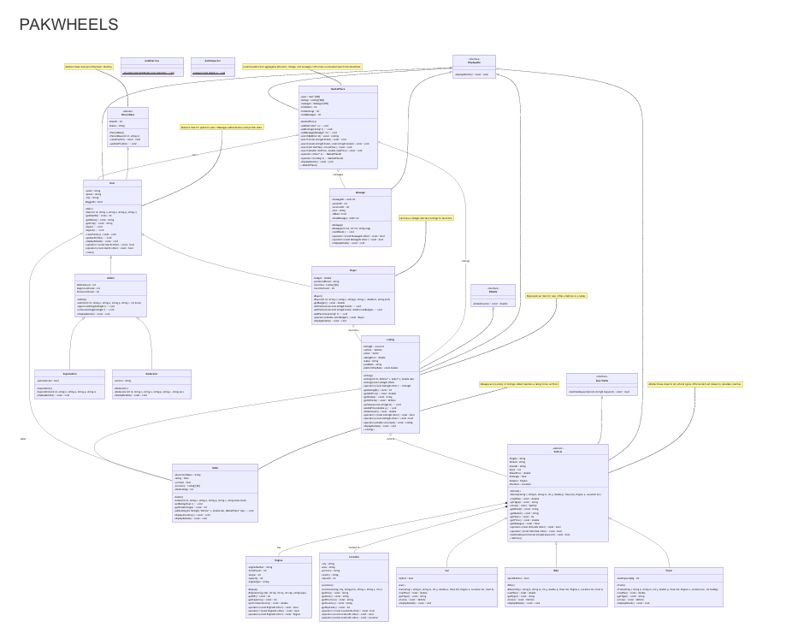

Program Inputs Required During Runtime
- Location input: City Area Province Country Zipcode
- Listing update input: Price Status

User Class

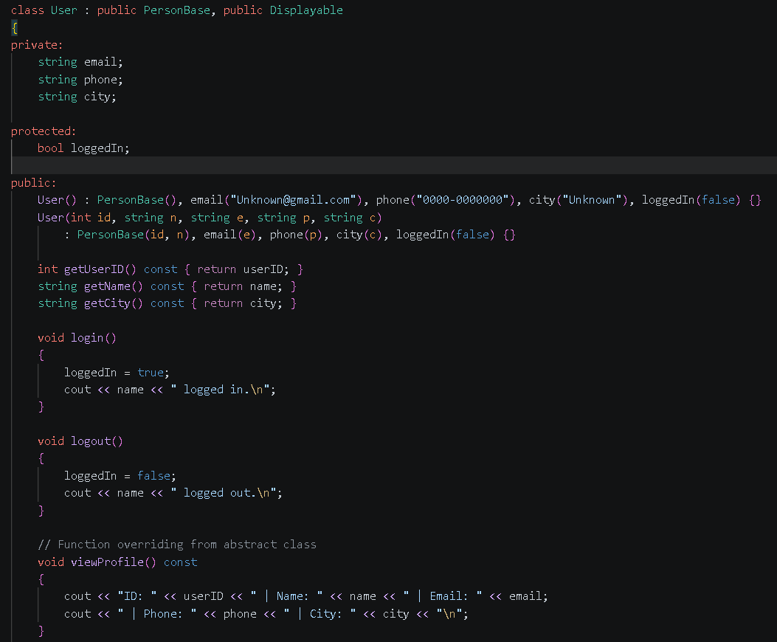

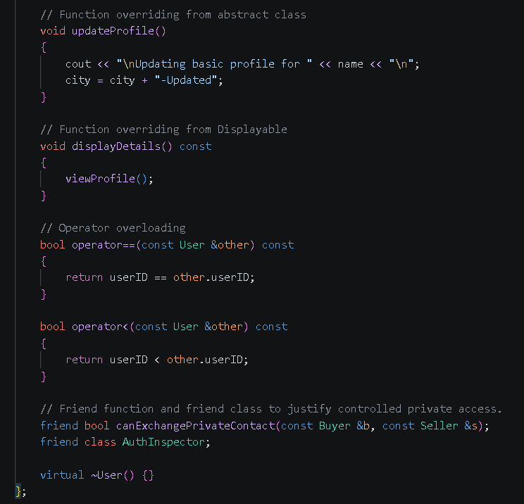

Vehicle Dashboard with Tax

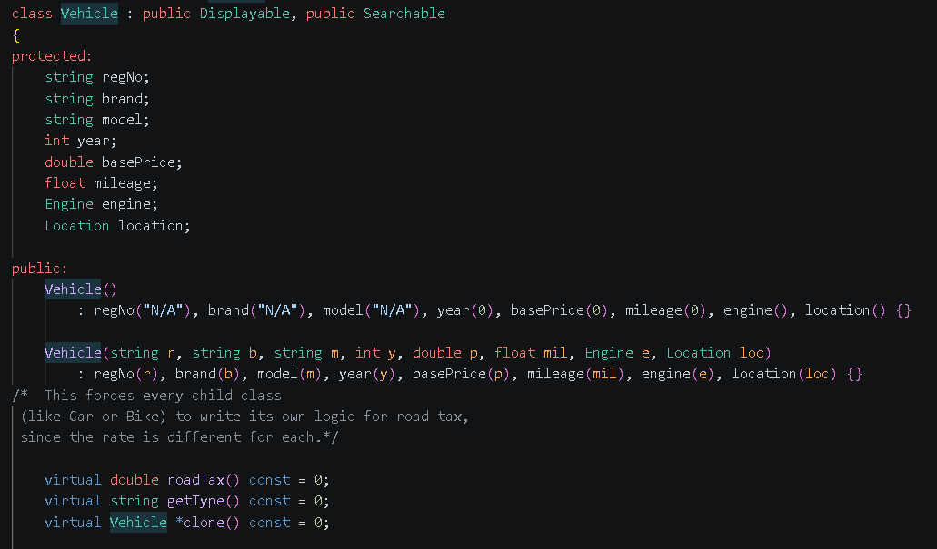

For Cars

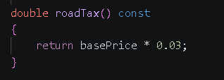

For Bike

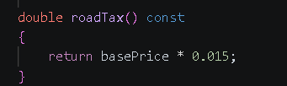

For Truck

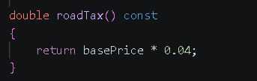

Main:

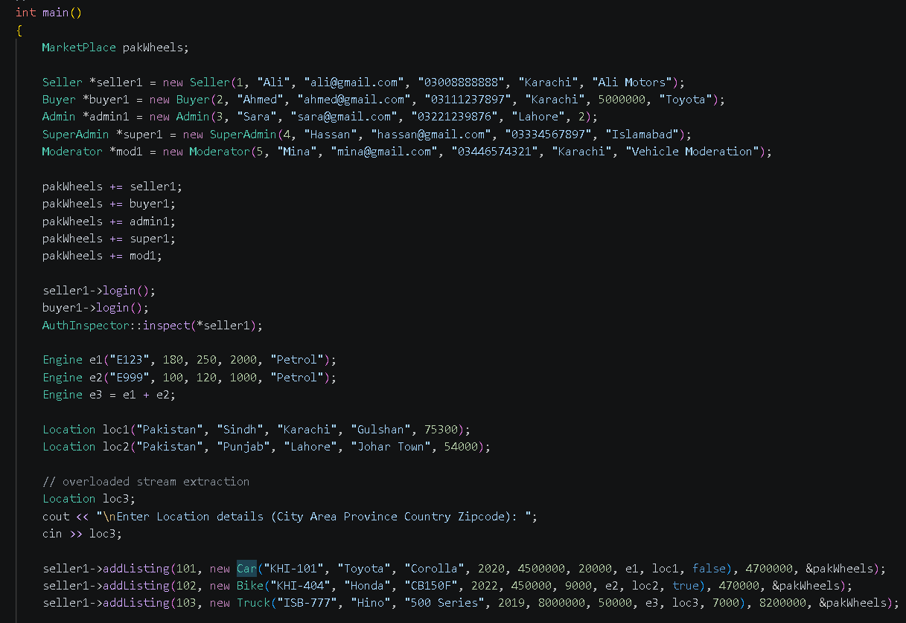

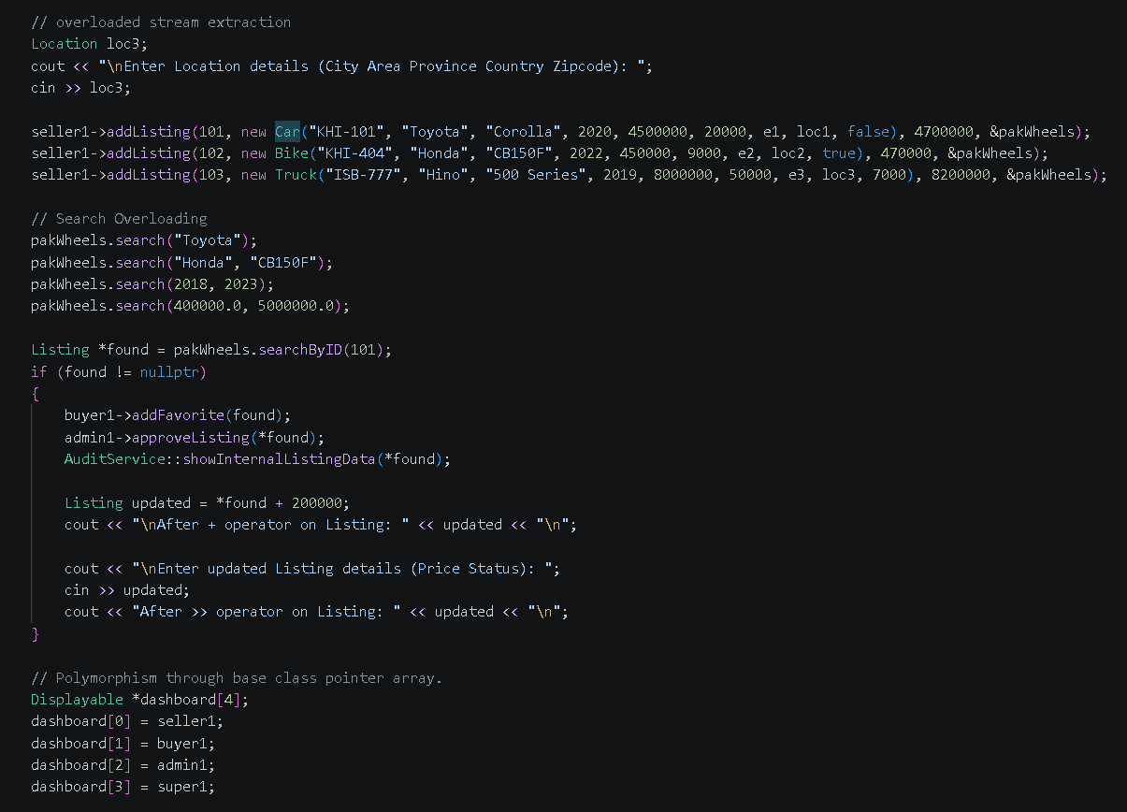

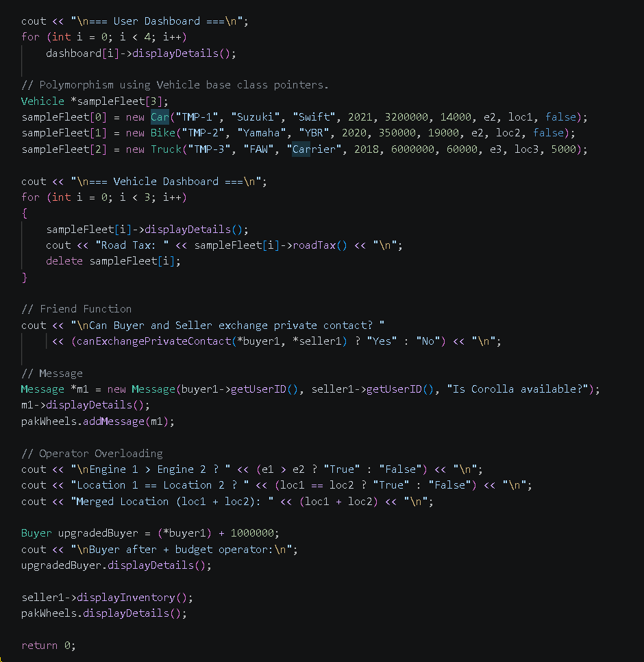

Website Screenshots

Display:

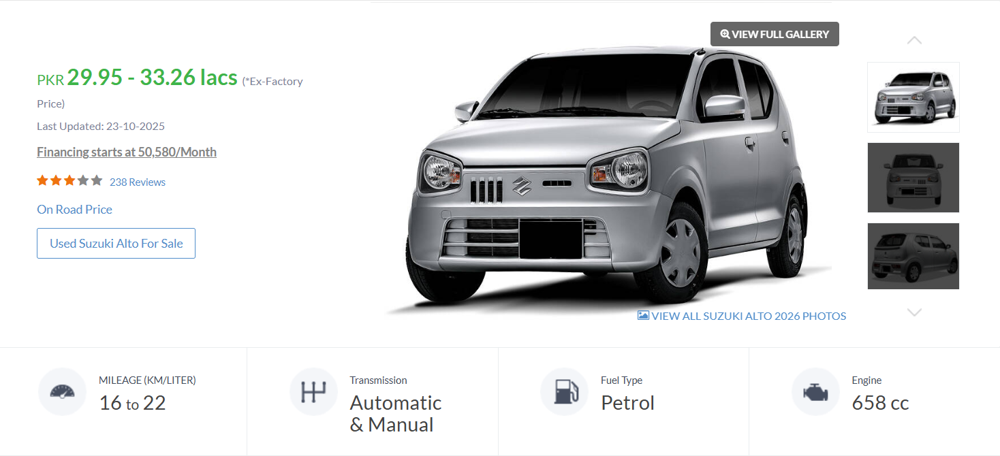

Specs:

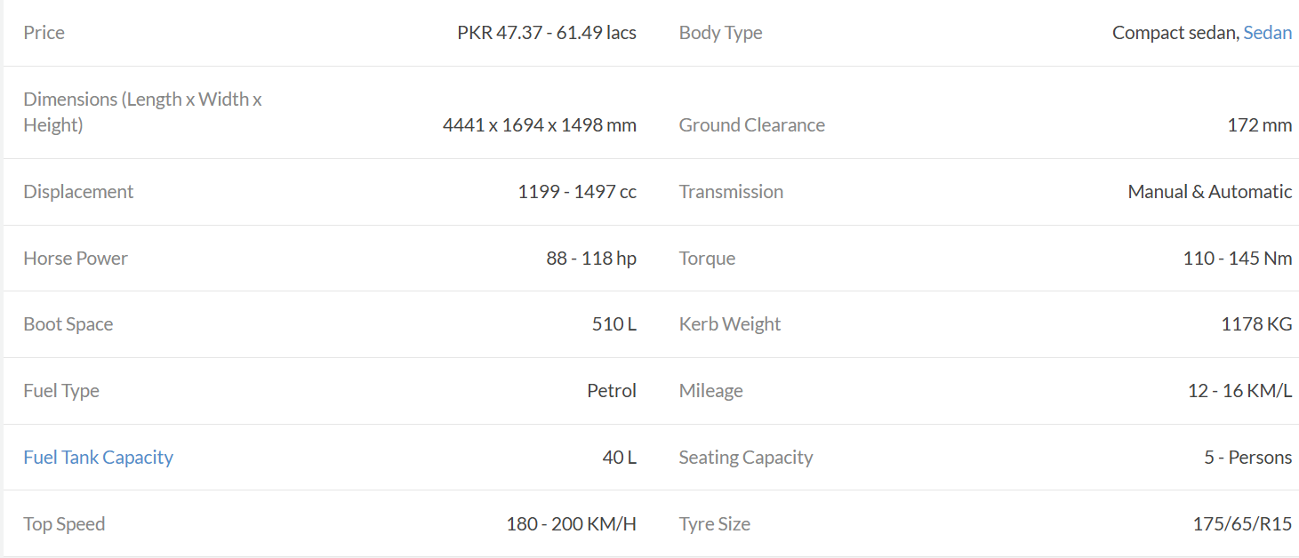

User Details:

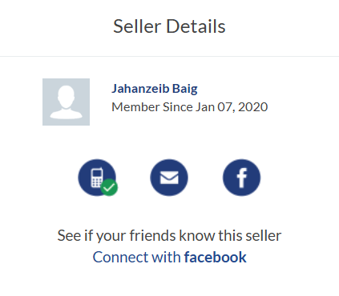

Message System:

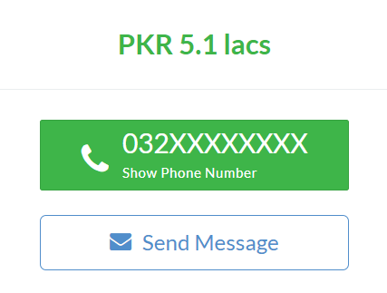

Add to Favorite Feature:

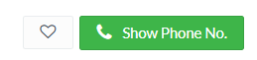

Car Comparison:

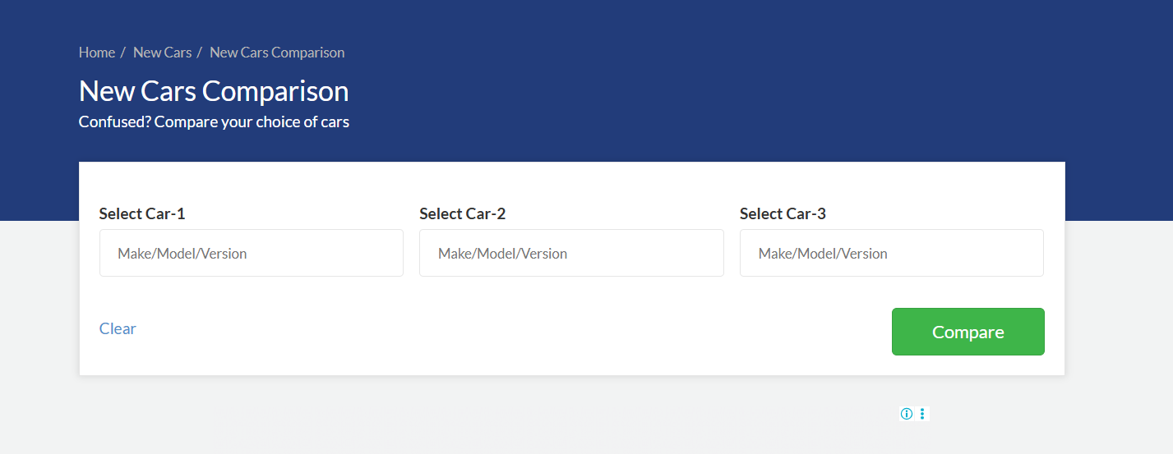

Find Cars:

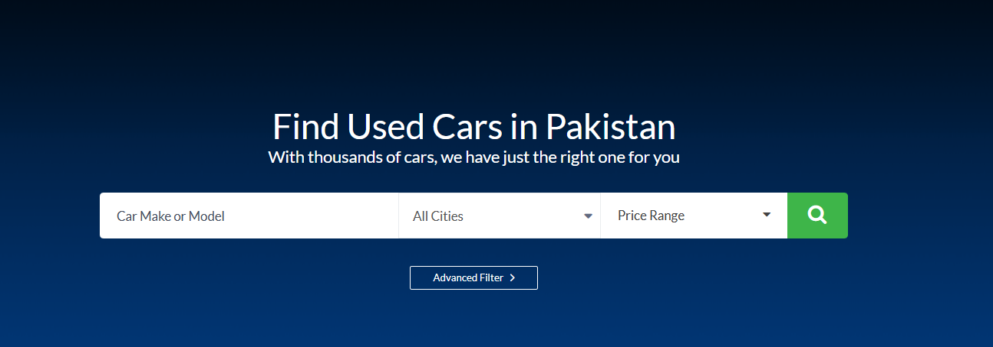

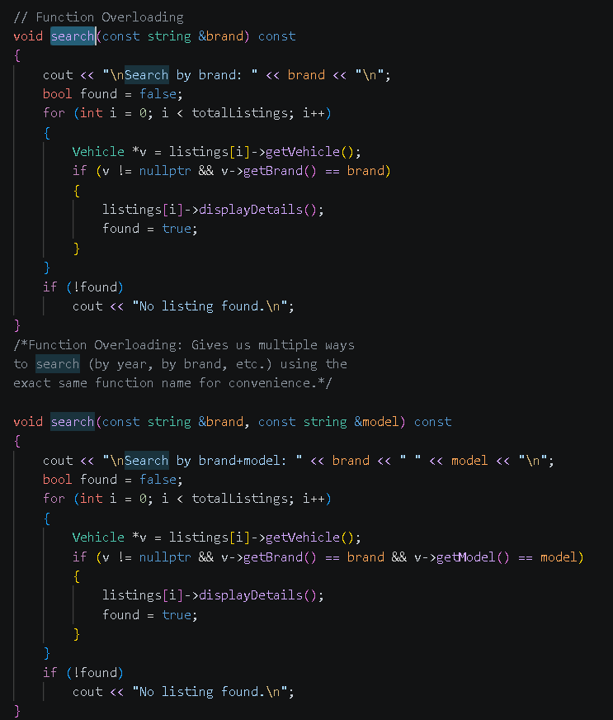

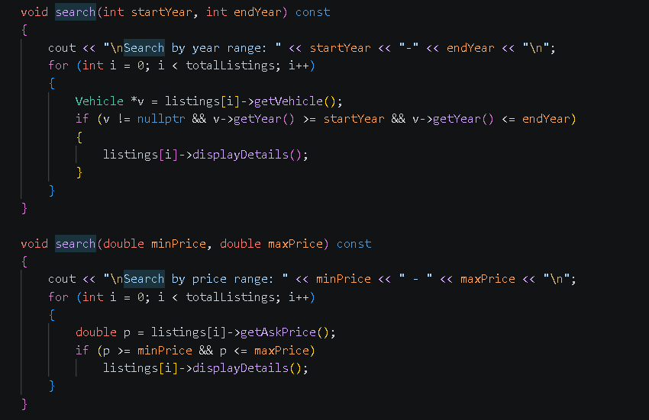

Car and Bike Types:

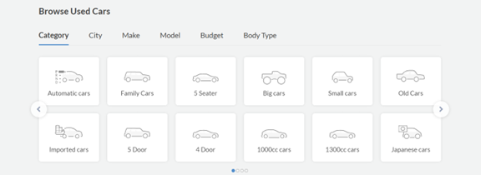

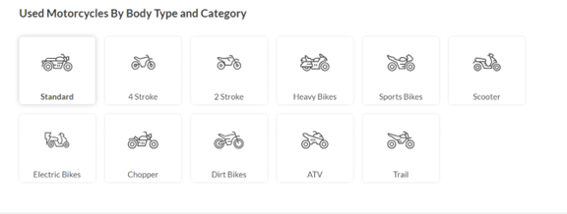

Final Output snippets:

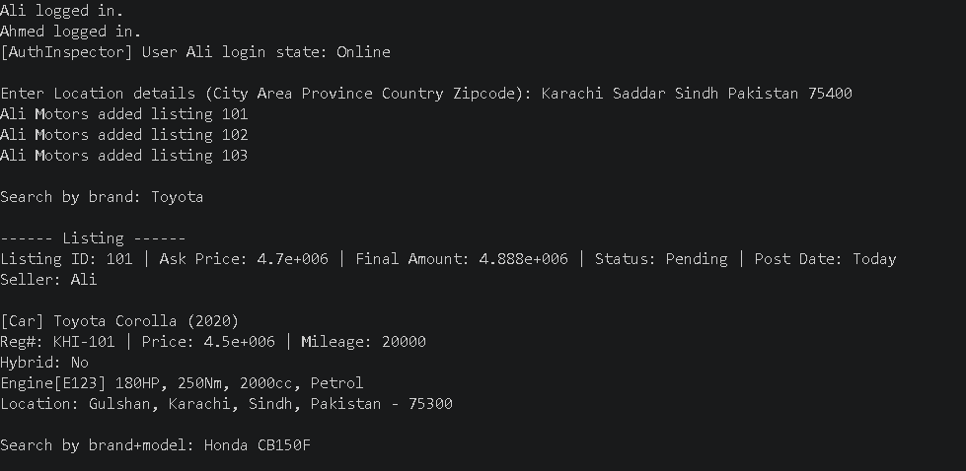

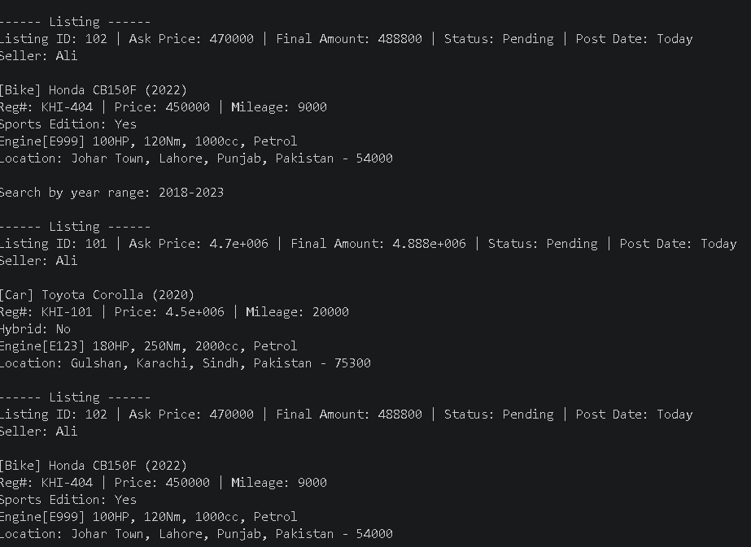

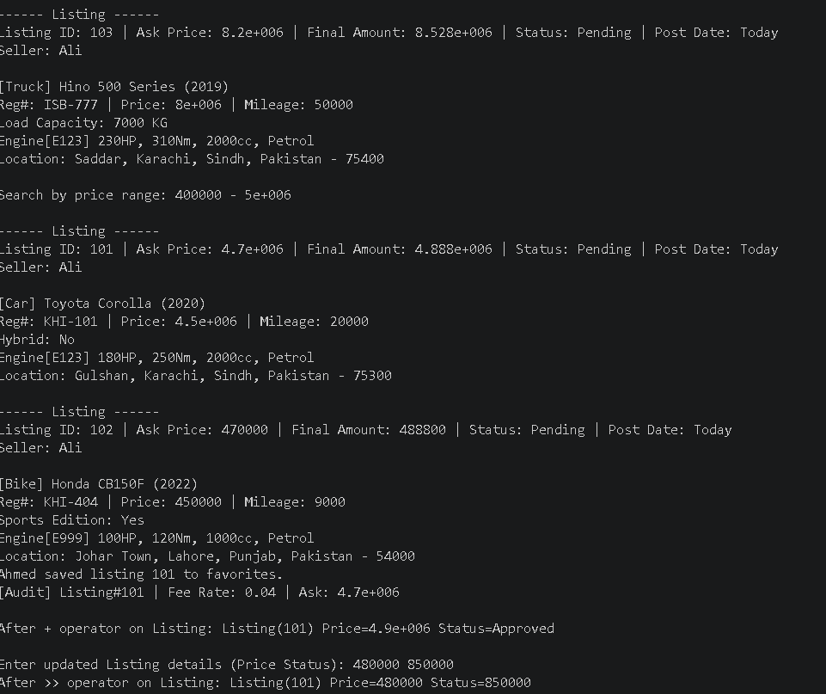

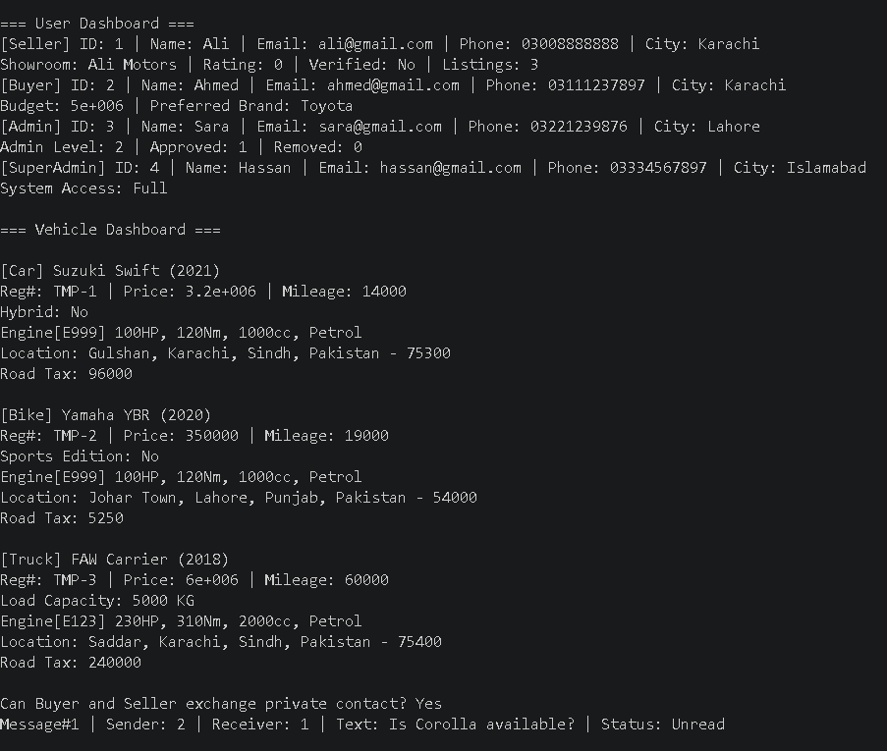

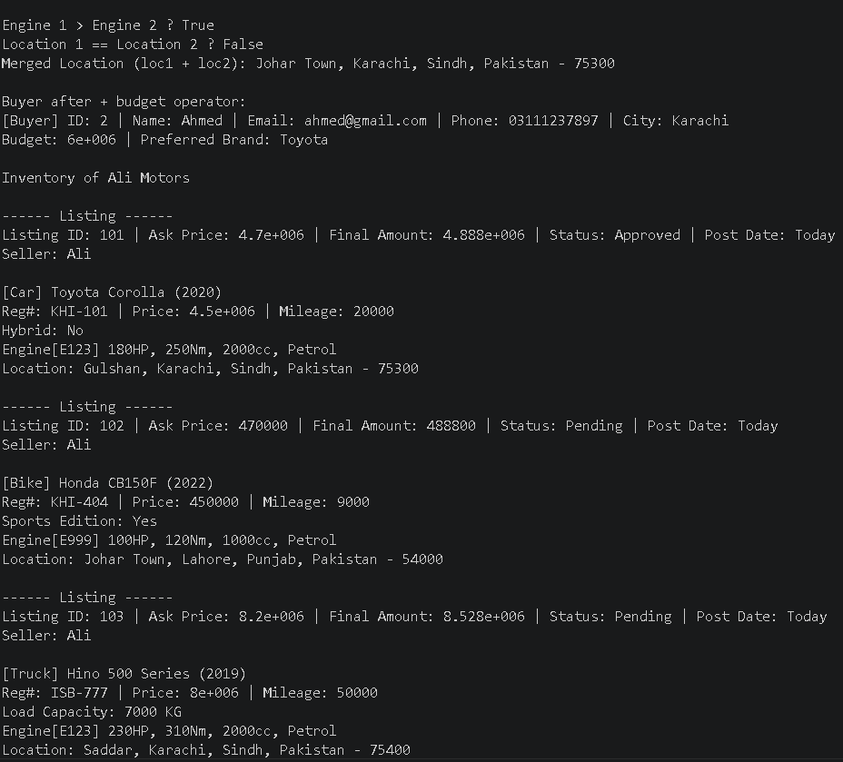

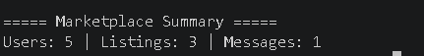

CONCLUSION
This assignment successfully demonstrates all core OOP principles in C++ through a realistic marketplace domain. The project applies abstraction through interfaces and abstract classes, inheritance through multi-level role and vehicle trees, runtime polymorphism through virtual dispatch, compile-time polymorphism through function overloading, and domain-driven operator overloading for expressive syntax.
The code also includes stronger concepts such as friend access control, deep-copy logic via polymorphic cloning in Listing , and deterministic cleanup through destructors. Overall, it is a complete OOP implementation with practical interactions between classes instead of isolated textbook examples.

